Monday Geology lab Take Home Quiz
Use separate sheets of paper to answer the following questions.
- For each relative dating principle, briefly explain how the principle is used to decipher Earth history and draw a diagram that illustrates each explanation.
Original Horizontality
Superposition:
Cross-cutting relations
Principle of Inclusions
Principle of Unconformities

- Using the an 8 X 11 sheet of paper (the entire paper), draw your own topographic map. Your map should include the following:
- multiple index contour lines with elevations,
- at least 2 creeks or rivers,
- contour interval,
- RF-scale and graphic scale
- magnetic declination
- one or more Township/Range lines, at least 2 sections,
- There should be two areas of steepness and two areas of gentle slopes shown on your contour lines.
Answer the following questions using your newly created topographic map.
- Plot two landmarks on your map and calculate the relief between the landmarks
- Choose one of your creeks/river and calculate the gradient
- Make up three locations on your map and write the legal description (PLSS) for each location.
- Indicate the direction of flow for each creek/river
- Choose an area on your map and construct a topographic profile

- Describe the following characteristics of P, S and surface waves.
How fast they travel, types of materials they travel through, types of motion they exhibit.

P – wave:

S- wave:

Surface wave
- An earthquake measuring 3.0 on the Richter scale occurs. Another earthquake measures 5.0 on the Richer Scale. How much more ground shaking did the 5.0 M have than the 3.0 M? How much more energy was released? What is the difference in magnitude steps?

- Draw a diagram that shows how the triangulation method is used to determine the location of an epicenter. Also, sketch a seismogram showing the S-P intervals for each seismograph station. Be sure to label the following: distance radius from the seismograph station, epicenter, and each seismograph station. Use a separate piece of paper.

- A seismogram shows an earthquake occurring at 19 hr 23min 42 sec and ends at 19hr 24 min 15 sec. The smallest amplitude is measured at .2 mm. The largest amplitude is measured at 3 mm. Complete the chart below and provide your answers in the blanks.

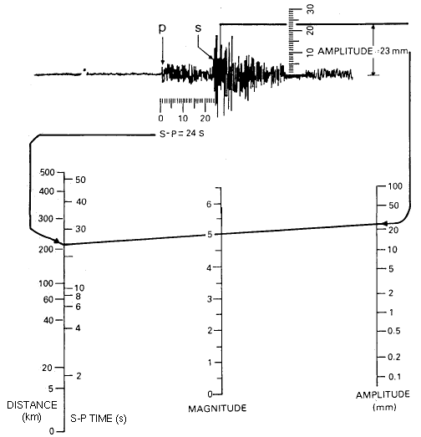

S – P interval ____________
Distance from epicenter ____________
Earthquake magnitude ____________

- Draw your own seismogram in the blank below showing an earthquake. Make sure you can determine the P and S wave arrivals, the S-P interval time, highest amplitude, and use this data along with the above table and show the magnitude and distance from the earthquake.

S-P interval ___________ Earthquake magnitude __________ Distance from epicenter _________

